Slovak Bridge Association
invites to

International Championship of Slovakia

Grand Prix Slovakia 2021

Date: September 24 to 26, 2021
Venue: Hotel Satel*** in Poprad

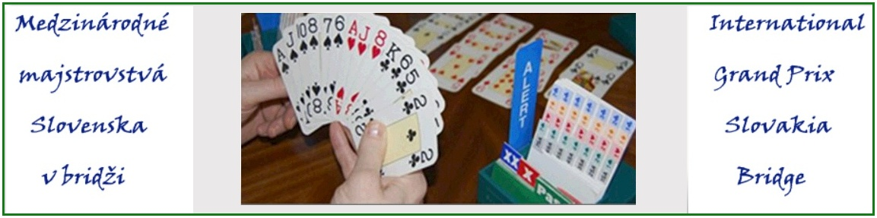

Tournament Director: Dušan Šlachta, Czech Republic

Programme:

Friday: Sept. 24, 2021 International Championship of Slovakia – GP 2021
Presentation closed - teams 2:30 p.m.
Teams competition, rounds 1 to 5 (Swiss) 3 p.m.

Saturday: Sept. 25, 2021 International Championship of Slovakia – GP 2021
Teams competition, rounds 6 to 9 (Swiss) 9:30 a.m.

Presentation closed - pairs 3:45 p.m.
Pairs competition, round 1 4 p.m.

Sunday: Sept. 26, 2021 International Championship of Slovakia – GP 2021
Pairs competition, round 2 9:30 a.m.
Prizegiving ceremony 2 p.m.

Entry Fees: 60,- EUR per team; juniors (born in 1998 and younger) 20,- EUR/all-junior team
40,- EUR per pair; juniors (born in 1998 and younger) 20,- EUR/all-junior pair

Entry Form: click here

Prizes:
Teams competition

1st prize 400 EUR, the winner’s challenge cup and small cups

2nd and 3rd prize according to financial contributions from sponsors and entry fees

Pairs competition

1st prize 600 EUR, the winner’s challenge cup and small cups

2nd to 6th prize according to financial contributions from sponsors and entry fees

Additional prizes and small cups will be awarded to the best ladies, mix, junior (born in 1998 and younger) and senior (born in 1959 and older) pairs.

Approximately 60% of the collected entry fees will be used for financial and other prizes.

Accommodation
Hotel Satel***, Mnoheľova 825, 058 01 Poprad
phone: +421 918 898720; e-mail:sales@hotelsatel.com
Price: 43,50 EUR per night in a single-bed room
55,50 EUR per night for a double-bed room
70,50 EUR per night in a triple-bed room
All the above prices are including buffet breakfast and local tax
Please refer to BRIDGE when booking.

Meals
Hotel Satel*** lunch and/or dinner (a two-course menu) 7,50 EUR

Antipandemic Measures
The condition for registering a participant is either a proof of full vaccination with a registered vaccine or a PCR test no older than 72 hours at the time of the start of the first competition in which the participant competes.
Participants arriving from abroad are obliged to register by filling the electronic form (https://korona.gov.sk/ehranica/) before entering the territory of Slovakia. In the form they will state whether they meet one of the exemptions from compulsory home isolation.

General Transport Conditions
Direct rail connections to Poprad by IC and/or EC trains,
Suitable road connections (mostly highways) with road networks of neighbour countries.

Additional Information
For participants and their guests there is a possibility to visit High Tatra mountains, the Aquacity water resort in Poprad, historical sights of the Spiš region, rafting on the Dunajec river in Pieniny National Park with experienced rafters dressed in original highlander costumes as well as other interesting attractions.

Further Information:
Vojtech Belčák, vojtechbelcak@iol.sk, phone: +421 908 700423, BBO nick: vojtech

